Swinburne University of Technology

School of Science, Computing and Engineering Technologies

Contribution Document

Subject Code: SWE30003 Unit Title: Software Architectures and Design

Assignment number and title: 3, Design Implementation Due date: 26th May 2026

Tutorial Day and Time: Wednesday 5:30 p.m Project Group: 05

Tutor: Mandeep Dhindsa

- Time spent (hours): fill in the time spent on each significant work item in the following table.

Work Item | Tran Duc Anh Dang | Saw Ko Ko Oo | Luan Nguyen | Ertesam Naser Zarif
Code Implementation | ✔ (2 weeks) |  | ✔ (1 week)
Abstract | ✔ (0.5 hour) | ✔ (0.5 hour)
Introduction | ✔ (0.5 hour) |  |  | ✔ (0.5 hour)
Detailed Design | ✔ (2 hour) | ✔ (2 hour) | ✔ (2 hour) | ✔ (2 hour)
Implementation | ✔ (2 hour) | ✔ (2 hour) |  | ✔ (2 hour)
Execution and Operation |  | ✔ (2 hour) | ✔ (2 hour) | ✔ (2 hour)
Discussion of Assignment 2 Design |  | ✔ (2 hour) | ✔ (2 hour) | ✔ (2 hour)
References | ✔ (5 minutes)
Total | 2 weeks 5 hours and 5 minutes | 8.5 hours | 1 week 6 hours | 8.5 hours
Note: Please adjust and add more rows, as necessary.
Description of contributions (each member provides a brief description of their contributions):

Tran Duc Anh Dang: I led the code implementation for two weeks, developed the core system functionalities, wrote the abstract and introduction, and contributed to the detailed design, implementation, and references. Luan and I are usually in voice together so we keep things up to date.

Saw Ko Ko Oo: I wrote on the abstract and introduction, detailed design, and execution and operation scenarios. I also contributed to the discussion of Assignment 2 Design.

Luan Nguyen: I assisted with code implementation for one week, worked on the detailed design, implementation, and contributed to execution and operation scenarios and the discussion of Assignment 2 Design.

Ertesam Naser Zarif: I contributed to the introduction, detailed design, implementation, and focused on execution and operation scenarios and the discussion of Assignment 2 Design.

- Evidence of collaboration / teamwork on each 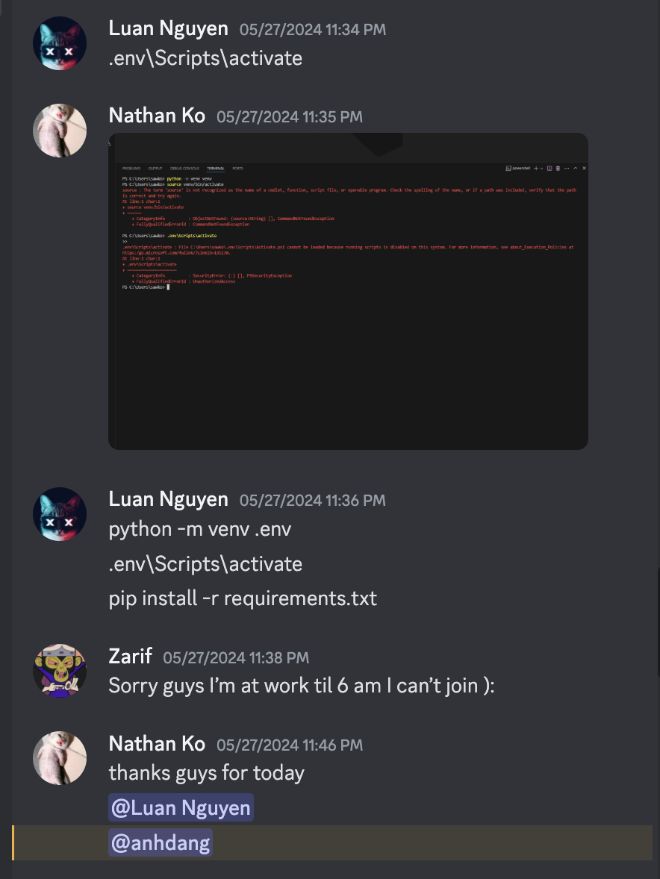
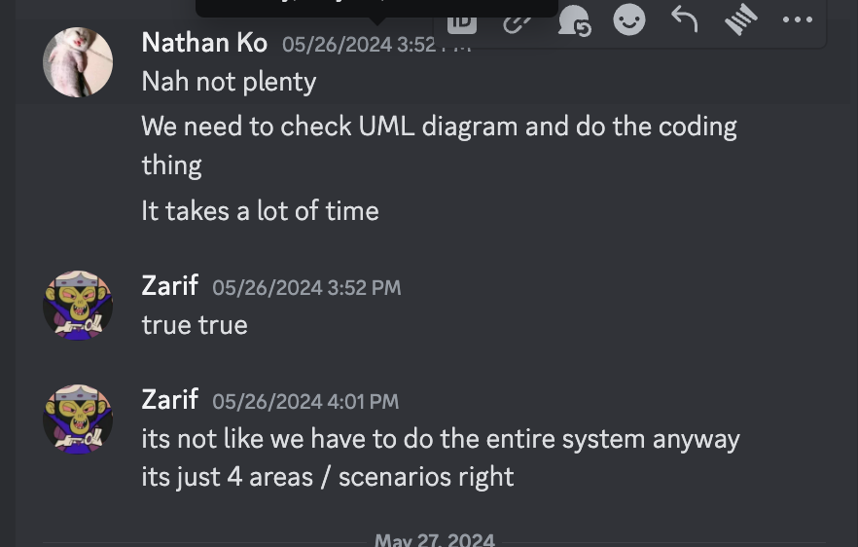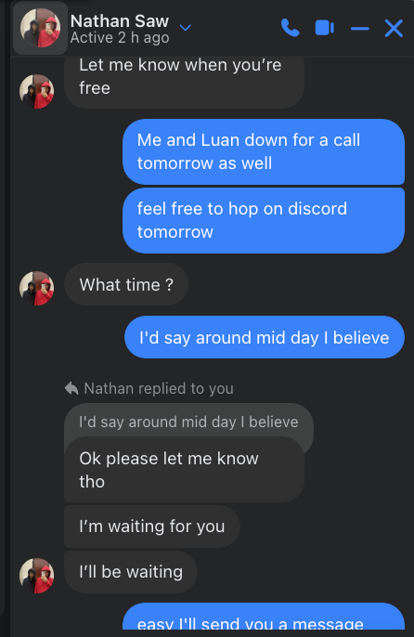

- Signed by all members:

ID Number Name Signature
103995439 Tran Duc Anh Dang Anh

103834192 Ertesam Naser Zarif

104150310 Nathan Ko Nathan

__103812143 Luan Nguyen Luan

